Automated OSINT Entity Resolution and Identity Disambiguation Engine

Category: Cybercrime Prevention & Open Source Intelligence
Author: Palcheen Srivastava
Affiliation: Amity University Noida
Date: 18 May 2026

Problem Statement
During digital investigations, law enforcement frequently encounters fragmented suspect data (e.g., an isolated username, an alias, or a general location). Existing public search tools return excessive "false positives," requiring cyber analysts to manually filter through hundreds of profiles. Furthermore, threat actors employ operational security (OPSEC) by leaving primary profiles blank, making traditional tracking difficult.

Proposed Solution (The Prototype)
This project introduces a Python-based OSINT engine designed to automate identity disambiguation. Instead of basic data scraping, this prototype utilizes a custom scoring algorithm. It cross-references a known "seed" clue against public APIs, filtering out false positives to isolate the verified suspect with a computed confidence score.

Functional Architecture
The prototype is built using a modular Python architecture:
- Data Gatherers: Authorized API integrations (currently utilizing the GitHub API as a Proof of Concept, with planned expansions to multi-site scanners like Sherlock).
- The Scoring Brain: A custom algorithm that assigns weighted points (e.g., +40 for location matches, +20 for activity indicators) to raw scraped data.
- Intelligence Output: An automated terminal dashboard that generates a clean intelligence report and confidence score for the investigator.

Prototype Demonstration

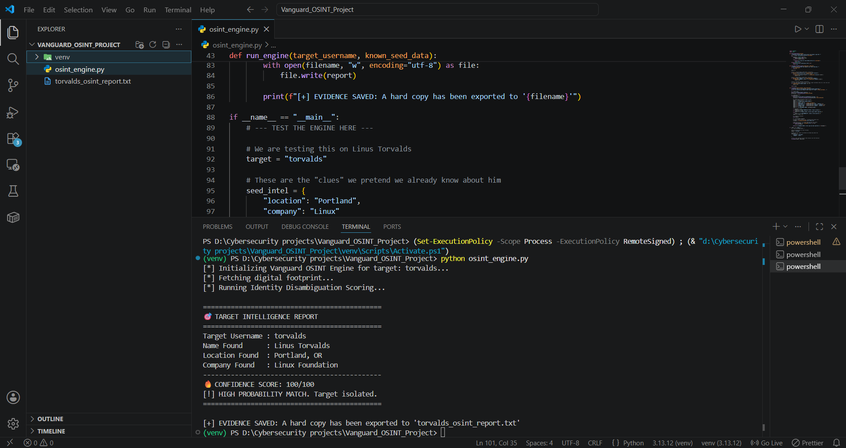

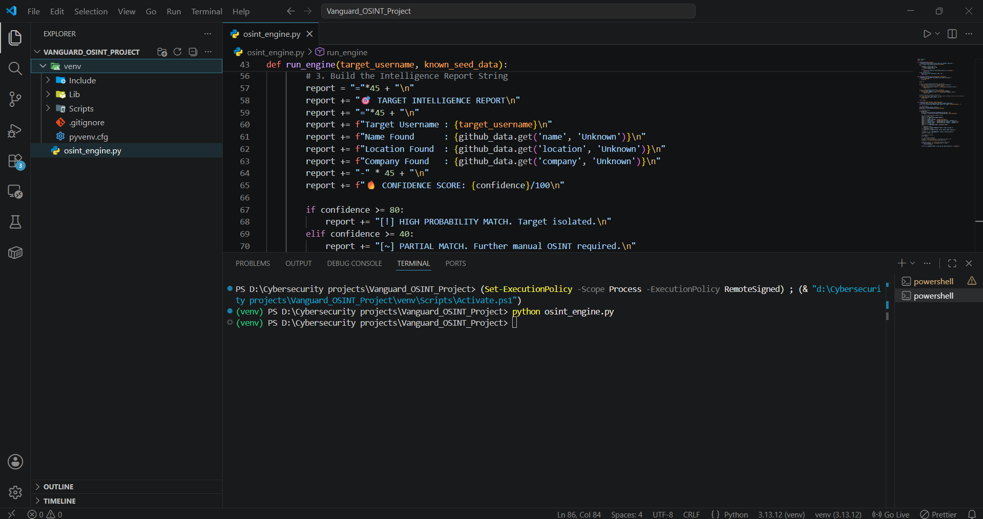
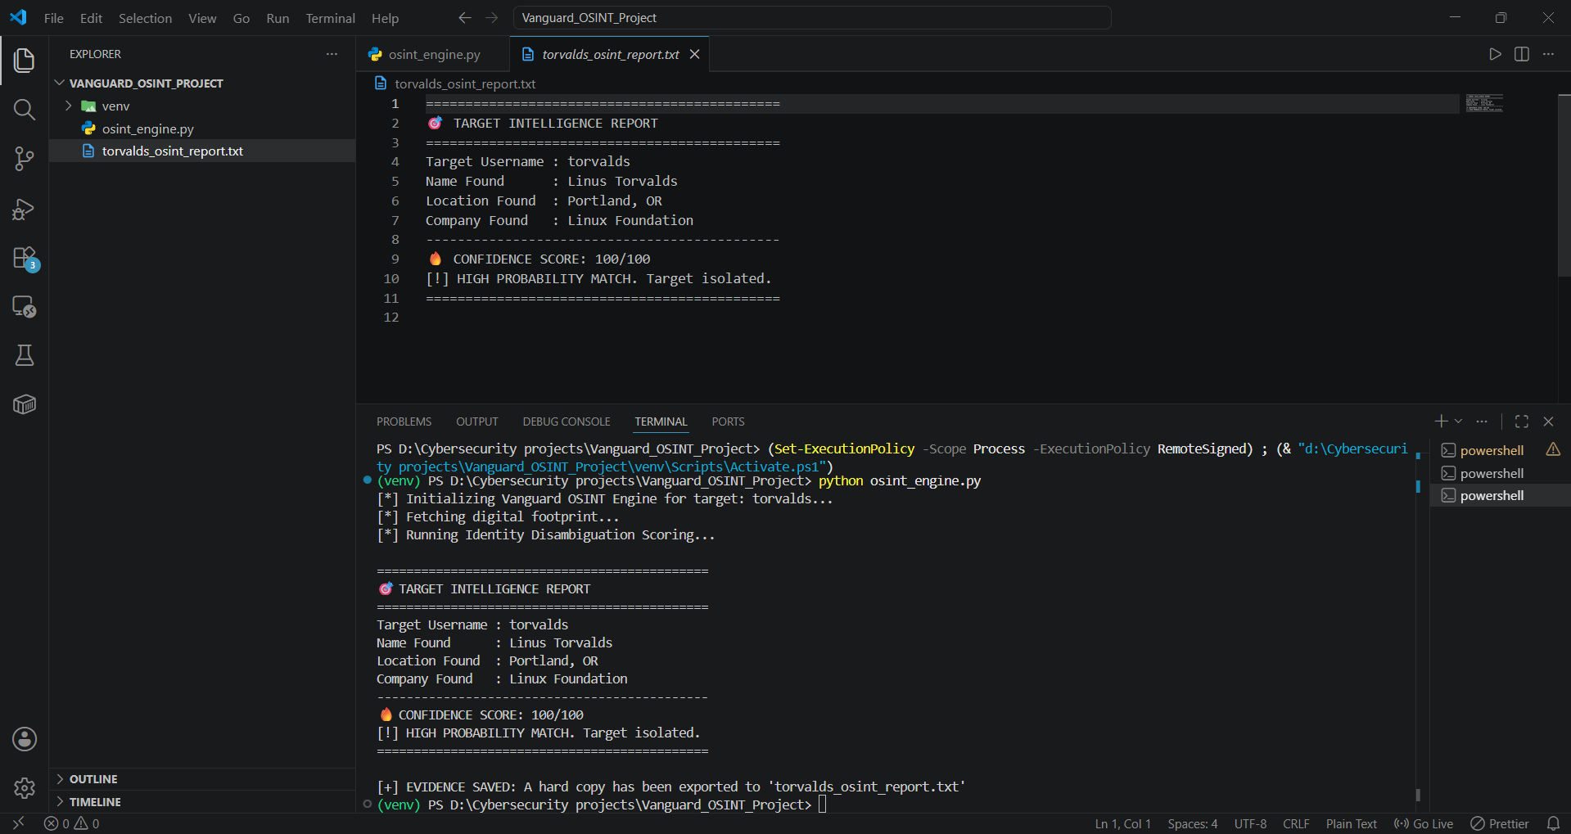
Fig 1: The engine successfully identifying a target using seed data cross-referencing.

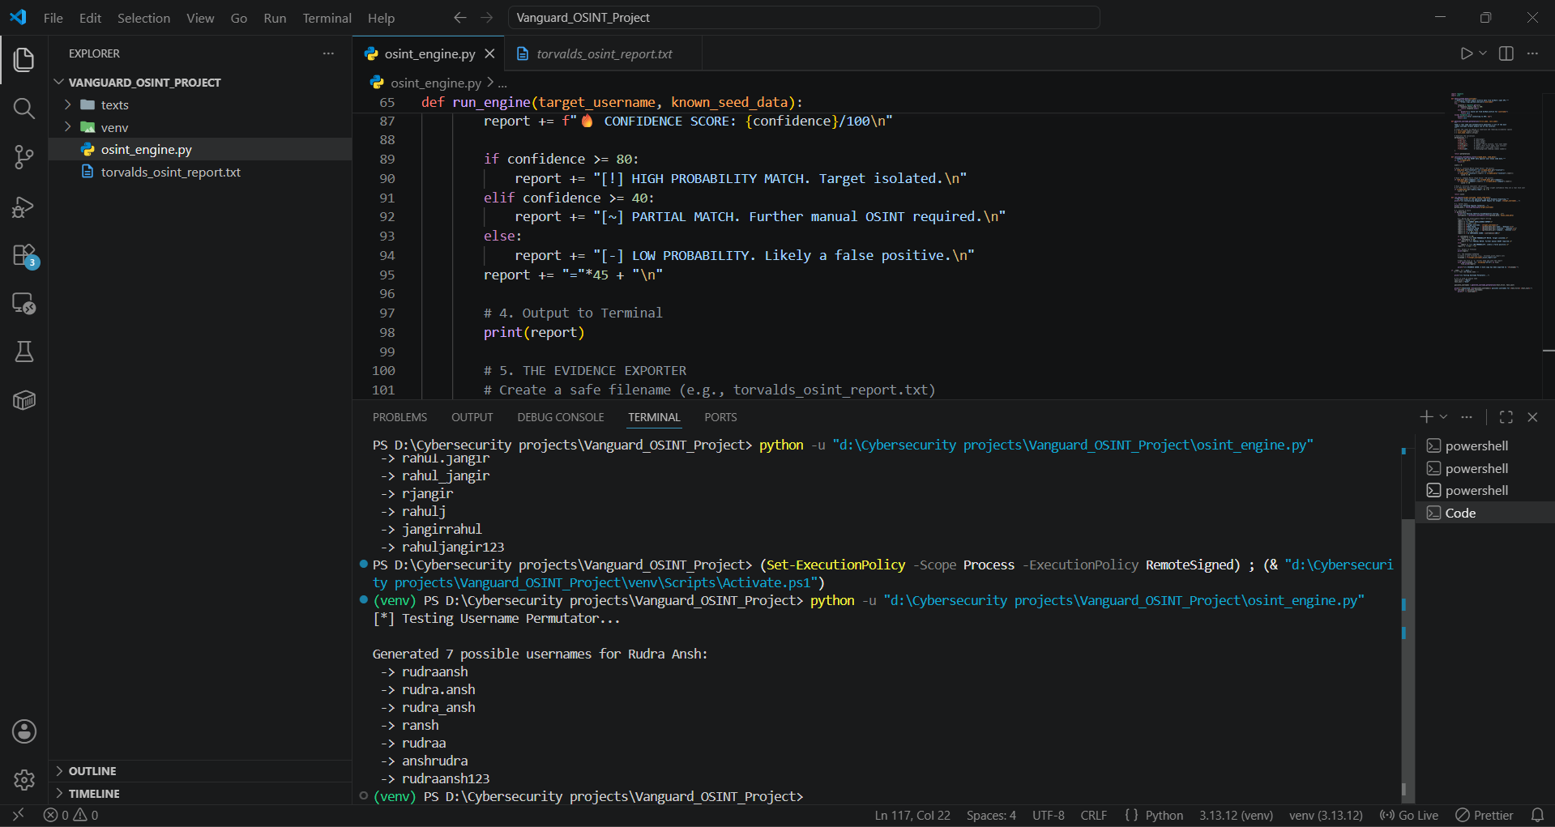

Fig 2: The engine correctly identifying a low-probability match due to lack of correlative data.

Future Scope & Law Enforcement Application
While the current working prototype successfully demonstrates the scoring algorithm on a single platform, the roadmap for this research includes:
Feature | Law Enforcement Value
Multi-Site Scanning | Integrating automated checks across 300+ platforms simultaneously to catch suspects who leave one profile blank but fill out another.
Pattern-of-Life (PoL) Analysis | Extracting timestamps from public activity to predict a suspect's timezone and sleep schedule.
Proactive Telegram Bots | Expanding the toolset to include automated bots that safely monitor open cybercrime syndicates on messaging platforms to gather proactive threat intelligence.

GitHub Repository
The codebase and future updates for the Vanguard OSINT engine can be found at the following repository:
GitHub Link: https://github.com/Palcheen02/Automated-OSINT-Entity-Resolution-and-Identity-Disambiguation-Engine-]

